MM Master Data
MM主数据
Scenario and Design Document



Document: HC_SAP_DD_MM01_MM Master Data
Version 1.2

PREPARED BY:
PRINTED NAME | TITLE | SIGNATURE / DATE
Meos Xu | MM Lead | 07/22/2025

APPROVED BY:
PRINTED NAME | TITLE | SIGNATURE / DATE
Rocky Cai | Project Manager
Jelly Ding | Purchasing
Yu Xiaodong | Purchasing
Cherry Qu | Purchasing
Xiaoqin Zhuo | Procurement
Lin Zhang | Procurement
Nancy Zhang | SCM
Sylvia Zhu | Planner
Irene Liu | Planner
Enly Teng | Logistics
Yining Xu | Master data maintenance
Junfeng Shen | R&D

Table of Contents

1. Guidelines 6
1.1 Design Document Approval Overview 6
1.2 Design Document Approval Options​ 6
2. MM Master Data 6
2.1 Introduction 6
3. Scenarios 7
3.1 Maintain Material Master 7
3.1.1 Purpose 7
3.1.2 Business Reason 7
3.1.3 Business Benefits 9
3.1.4 Business Process Flow 9
3.1.5 Business Process Steps 10
3.1.6 Home Control Business Requirements 12
3.1.7 HC Delegation Of Authority 13
3.1.8 Standard Documents / Settings 13
3.1.9 Design Considerations / Key Assumptions 13
3.1.10 Support / Closing Considerations 18
3.1.11 Integration Dependencies 18
3.2 Maintain Business Partner - Supplier Master 18
3.2.1 Purpose 18
3.2.2 Business Reason 18
3.2.3 Business Benefits 20
3.2.4 Business Process Flow 20
3.2.5 Business Process Steps 20
3.2.6 Home Control Business Requirements 21
3.2.7 HC Delegation Of Authority 22
3.2.8 Standard Documents / Settings 22
3.2.9 Design Considerations / Key Assumptions 22
3.2.10 Support / Closing Considerations 23
3.2.11 Integration Dependencies 23
3.3 Create Purchasing Info Record and Source List and Quota Arrangement 23
3.3.1 Purpose 23
3.3.2 Business Reason 24
3.3.3 Business Benefits 25
3.3.4 Business Process Flow 25
3.3.5 Business Process Steps 27
3.3.6 Home Control Business Requirements 28
3.3.7 HC Delegation Of Authority 28
3.3.8 Standard Documents / Settings 28
3.3.9 Design Considerations / Key Assumptions 28
3.3.10 Support / Closing Considerations 29
3.3.11 Integration Dependencies 29
4. Authorization Roles 30
4.1 Key Apps 30
4.2 Authorization Roles 30
5. Document Types and Document Flow 31
6. Reports, Interfaces, Conversions, Enhancements, Forms, and Workflows 31
6.1 Reports 31
6.1.1 Standard Reports 31
6.1.2 HC Requested Reports 32
6.2 Interfaces 32
6.3 Conversions 32
6.4 Programs 33
6.5 Enhancements 33
6.6 Forms 33
6.7 Workflows 33
7. Legend for Process Flow 34

Document Version History

Version | Summary of Change | Effective Date
1.0 | Create the initial version of the document. | 07/22/2025
1.1 | Change the process of Materials master data by comments | 08/12/2025
1.2 | Add some comments of material master and add the process of employee BP. Change the process of info record. | 08/14/2025

- Guidelines
  - Design Document Approval Overview
The SAP Implementation Project Design Documents are the result of the Fit / Gap workshops. All Project Design Documents must be reviewed and approved by the Home Control team to confirm we have captured the appropriate requirements as well as gaps, proposed solutions, and RICEFW objects​ from the workshops.
SAP Design Documents are living, breathing documents. As the SAP system is configured, tested, modified, and approved, the design documents may be updated to reflect the final design​.
ISS Team Leads create the original design documents​. Should Home Control decide to update the Design Documents, it is up to Home Control to perform the updates.
As we leave the Explore stage and enter the Realize stage, we ask for approval but understand that there may be open decisions or uncertainty in some areas. Therefore, we provide the following approval options.
  - Design Document Approval Options​

Sign-Off Without Reservation​
  - No issues or concerns​ at this point

Sign-Off with Reservation​
  - Minor issues or concerns (3-5) that need to be finalized during Realize stage.
  - Place Reservation(s) on the Issues Log, assign owner and due date, manage​ issue/concern.

Withhold Sign-Off - Major Decisions Unresolved​
  - Major design issues that need to be resolved in order to move forward in Realize stage (e.g., Internal Orders vs. Project Systems​)
  - Place on the Issues Log, assign owner and due date, manage​ issue
  - Complete Key Design Decision document and escalate (PMO then Executive Sponsor)

If you have any items that may withhold signature it is your responsibility to escalate as soon as possible

- MM Master Data

  - Introduction
The document focuses on maintaining Master Data related to Materials Management.

- Scenarios

The document covers the following scenarios:
  - Maintain Material Master
  - Maintain Business Partner – Vendor/Supplier Master
  - Maintain Purchasing Information Record
  - Maintain Source List
  - Maintain Quota Arrangement

  - Maintain Material Master
    - Purpose

This process is used to create and maintain Material Master.

    - Business Reason

The Material Master contains information on all the materials that a company procures or produces, stores, and sells. It is the company's central source for retrieving material-specific data. This information is stored in individual Material Master records.

The Material Master is used by all components in the SAP Logistics System. The integration of all material data in a single database object eliminates redundant data storage. In the SAP Logistics System, the data contained in the Material Master is required, for example, for the following functions:
- In Purchasing, for ordering
- In Inventory Management, for goods movement postings and physical inventory
- In Invoice Verification, for posting invoices
- In Sales and Distribution, for sales order processing
- In Production Planning & Control, for material requirements planning, scheduling, & work scheduling

Material master structure follows organizational structure of a company:
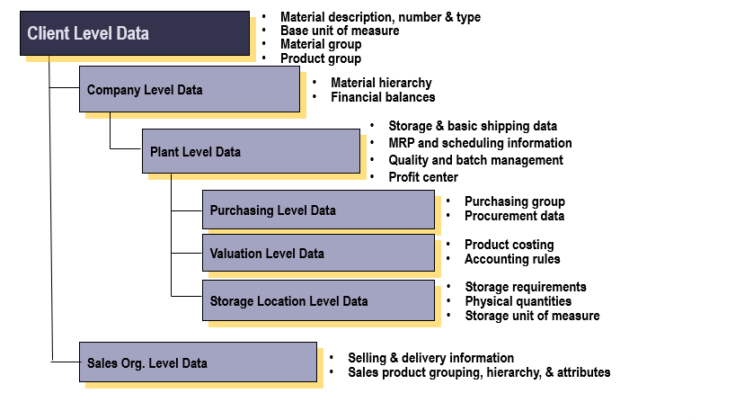

    - Business Benefits
    - Business Process Flow
    - Business Process Steps

Step | Step Name | Role | SAP App Name | Expected Results
001A | Requirement for creation of FG material | Project Team | Non-SAP | FG/Mechanical parts need to apply for external material numbers in the Smart-Fulfillment System.
002A | Maintain Material Master with Basic Data view and classification | Project Team | Non-SAP | After checking in Smart-Fulfillment System, call the materials master data interface to create.  Some fields in the material need to have their default values maintained; for details, refer to the field value XML file in section 3.1.9.  Set the status of material to ZA
001B | Requirement for creation of raw material | R&D | Non-SAP | The other materials type use the numbers provided internally by Smart-Fulfillment System.
002B | Maintain Material Master classification and default values in Finance view | R&D | Non-SAP | Some of the fields will be mandatory and other optional.  Some fields in the material need to have their default values maintained; for details, refer to the field value XML file in section 3.1.9.  Set the status of material to ZA
003 | FG or Raw material? (Decision) | R&D | Non-SAP
004 | Maintain MRP view, Finance views, Procurements views, Sales view (If 008=No) | Master Data Team | Non-SAP | After checking in Smart-Fulfillment System, call the materials master data interface to change or create.  Some fields in the material need to have their default values maintained; for details, refer to the field value XML file in section 3.1.9.  Set the status of material to ZB
005 | Maintain MRP view, Price, Procurements view (If Raw material) | Purchasing | Non-SAP | After checking in Smart-Fulfillment System, call the materials master data interface to change or create.  Some fields in the material need to have their default values maintained; for details, refer to the field value XML file in section 3.1.9.  Set the status of material to ZB
006 | If Kitting materials? (Decision) | Purchasing | Non-SAP
007 | Maintain Sales view (If 006=Yes) | Master Data Team | Non-SAP | After checking in Smart-Fulfillment System, call the materials master data interface to change or create.  Some fields in the material need to have their default values maintained; for details, refer to the field value XML file in section 3.1.9.  Set the status of material to ZB
008 | If need to maintain info record? (Decision) | Master Data Team | Non-SAP | If material do not need to maintain info record, set the status of material to ZN  Some fields in the material need to have their default values maintained; for details, refer to the field value XML file in section 3.1.9.
HC_SAP_DD_MM01_03 | MM Purchasing Info Record and Source List (Parallel Flow) | Purchasing | Non-SAP | After maintaining info record, set the status of material to ZC  Some fields in the material need to have their default values maintained; for details, refer to the field value XML file in section 3.1.9.
009 | Check and Verify the data | Master Data Team | Non-SAP
010 | Run costing of materials | Finance | / | Run the cost of materials
011 | Change the material status | Finance | Non-SAP | Changing material status in Smart-Fulfillment System and transferring to SAP  After running cost,set the status of material to ZD.  If need to change the status, the special status ZT is also available.
012 | Check Material data in SAP | Finance | Manage Product Master Data/Export Master Data - Products | Check the data in SAP

    - Home Control Business Requirements
- Home Control will use the following material types:
Material Type | Material type description
ZFER | Home Control Finished Gds
ZH01 | Diode
ZH02 | Colour LED
ZH03 | IR LED / IR Receiver
ZH04 | Transistor
ZH05 | Others Active Component
ZH06 | Capacitor, Tancap
ZH07 | Inductor
ZH08 | Crystal / Resonator
ZH09 | Resistor_PTC
ZH10 | Others Passive Component
ZH11 | Microcontroller (Blank)
ZH12 | Standard IC
ZH13 | Connector / Cable
ZH14 | Switch
ZH15 | Others (EM)
ZH16 | Battery
ZH17 | Chemical (Glue, Solder)
ZH18 | Collect Code_Transistor
ZH19 | Collect Code_Capacitor
ZH20 | Collect Code_Resistor
ZH21 | SG_Internal metal & dome
ZH22 | SG_Ext basic tool part
ZH23 | SG_Printed label / manual
ZH24 | SG_Packaging
ZH25 | SG_Mechanical Assy
ZH26 | SG_PWB
ZH27 | SG_Programming IC
ZH28 | SG_PWB Assy / SMD Assy
ZH29 | SG_Sketch Code
ZH30 | SZ_Internal metal & dome
ZH31 | SZ_Ext basic tool part
ZH32 | SZ_Printed label / manual
ZH33 | SZ_Packaging
ZH34 | SZ_Mechanical Assy
ZH35 | SZ_PWB
ZH36 | SZ_Programming IC
ZH37 | SZ_PWB Assy / SMD Assy
ZH38 | SZ_Sketch Code
ZH39 | Simand 13NC Semifinished
ZH40 | Mac Address
ZH41 | ODM Designed Parts
ZH42 | ODM Designed Parts-14NC
ZH43 | SZ_Mech Module Assy
ZH44 | Non-valuated FG
ZHL1 | Semifinish&Comp(0XXX-3XXX
ZHL2 | Semifinish&Comp(8XXX-9XXX

- Materials with assigned numbers exist in a legacy ERP system today. The material master data will inherit the material types, number ranges, and material numbers from the original SAP ERP.
- New material numbers created after go-live will be provided by the Smart-Fulfillment System, and the numbers in SAP ES will be externally assigned.
- Home Control will use Standard Costs for all Material Type.
    - HC Delegation Of Authority
- N/A
    - Standard Documents / Settings
- N/A
    - Design Considerations / Key Assumptions

- Separate number range can be assigned based on Material Type.
- Material types will be assigned external number range.
Material Type | Material type description | From | To
ZFER | Home Control Finished Gds | A | ZZZZZZZZZZZZZZZZZZ
ZH39 | Simand 13NC Semifinished | A | ZZZZZZZZZZZZZZZZZZ
ZH44 | Non-valuated FG | A | ZZZZZZZZZZZZZZZZZZ
ZHL1 | Semifinish&Comp(0XXX-3XXX | 000000000000000000 | 000000399999999999
ZHL2 | Semifinish&Comp(8XXX-9XXX | 000000800000000000 | 000000999999999999
ZH01 | Diode | 000000501010000000 | 000000501010099999
ZH02 | Colour LED | 000000501020000000 | 000000501020099999
ZH03 | IR LED / IR Receiver | 000000501030000000 | 000000501030099999
ZH04 | Transistor | 000000501040000000 | 000000501040099999
ZH05 | Others Active Component | 000000501090000000 | 000000501090099999
ZH06 | Capacitor, Tancap | 000000502010000000 | 000000502010099999
ZH07 | Inductor | 000000502020000000 | 000000502020099999
ZH08 | Crystal / Resonator | 000000502030000000 | 000000502030099999
ZH09 | Resistor_PTC | 000000502040000000 | 000000502040099999
ZH10 | Others Passive Component | 000000502090000000 | 000000502090099999
ZH11 | Microcontroller (Blank) | 000000503010000000 | 000000503010099999
ZH12 | Standard IC | 000000504010000000 | 000000504010099999
ZH13 | Connector / Cable | 000000505010000000 | 000000505010099999
ZH14 | Switch | 000000505020000000 | 000000505020099999
ZH15 | Others (EM) | 000000505090000000 | 000000505090099999
ZH16 | Battery | 000000506010000000 | 000000506010099999
ZH17 | Chemical (Glue, Solder) | 000000509010000000 | 000000509010099999
ZH18 | Collect Code_Transistor | 000000555510000000 | 000000555510099999
ZH19 | Collect Code_Capacitor | 000000555520000000 | 000000555520099999
ZH20 | Collect Code_Resistor | 000000555530000000 | 000000555530099999
ZH21 | SG_Internal metal & dome | 000000601000000000 | 000000601000099999
ZH22 | SG_Ext basic tool part | 000000602000000000 | 000000602000099999
ZH23 | SG_Printed label / manual | 000000603000000000 | 000000603000099999
ZH24 | SG_Packaging | 000000604000000000 | 000000604000099999
ZH25 | SG_Mechanical Assy | 000000605000000000 | 000000605000099999
ZH26 | SG_PWB | 000000606000000000 | 000000606000099999
ZH27 | SG_Programming IC | 000000607000000000 | 000000607000099999
ZH28 | SG_PWB Assy / SMD Assy | 000000608000000000 | 000000608000099999
ZH29 | SG_Sketch Code | 000000723932900000 | 000000723932900001
ZH30 | SZ_Internal metal & dome | 000000661000000001 | 000000661099999999
ZH31 | SZ_Ext basic tool part | 000000662000000001 | 000000662099999999
ZH32 | SZ_Printed label / manual | 000000663000000001 | 000000663099999999
ZH33 | SZ_Packaging | 000000664000000001 | 000000664099999999
ZH34 | SZ_Mechanical Assy | 000000665000000001 | 000000665099999999
ZH35 | SZ_PWB | 000000666000000001 | 000000666099999999
ZH36 | SZ_Programming IC | 000000667000000001 | 000000667099999999
ZH37 | SZ_PWB Assy / SMD Assy | 000000668000000001 | 000000668099999999
ZH38 | SZ_Sketch Code | 000000723933900000 | 000000723933999999
ZH40 | Mac Address | 000000508010000000 | 000000508010099999
ZH41 | ODM Designed Parts | 000000400010000000 | 000000400010099999
ZH43 | SZ_Mech Module Assy | 000000669000000001 | 000000669099999999
ZH42 | ODM Designed Parts-14NC | 000030000000000000 | 000030999999999999

- Material number length will be limited to 18 characters
- Material Description Length is limited to 40 characters
- Valuation classes which represent inventory accounts are assigned to materials to segregate inventory by material type. The below Valuation classes will be assigned to material types:
Material Type | Valuation Class | Description
ZFER | 1106 | Comm.inv. FERT (OVH Subc)
ZH01 | 1006 | Prod inv SEMI (OVH Subc.)
ZH02 | 1006 | Prod inv SEMI (OVH Subc.)
ZH03 | 1006 | Prod inv SEMI (OVH Subc.)
ZH04 | 1006 | Prod inv SEMI (OVH Subc.)
ZH05 | 1006 | Prod inv SEMI (OVH Subc.)
ZH06 | 1006 | Prod inv SEMI (OVH Subc.)
ZH07 | 1006 | Prod inv SEMI (OVH Subc.)
ZH08 | 1006 | Prod inv SEMI (OVH Subc.)
ZH09 | 1006 | Prod inv SEMI (OVH Subc.)
ZH10 | 1006 | Prod inv SEMI (OVH Subc.)
ZH11 | 1006 | Prod inv SEMI (OVH Subc.)
ZH12 | 1006 | Prod inv SEMI (OVH Subc.)
ZH13 | 1006 | Prod inv SEMI (OVH Subc.)
ZH14 | 1006 | Prod inv SEMI (OVH Subc.)
ZH15 | 1006 | Prod inv SEMI (OVH Subc.)
ZH16 | 1006 | Prod inv SEMI (OVH Subc.)
ZH17 | 1006 | Prod inv SEMI (OVH Subc.)
ZH18 | 1006 | Prod inv SEMI (OVH Subc.)
ZH19 | 1006 | Prod inv SEMI (OVH Subc.)
ZH20 | 1006 | Prod inv SEMI (OVH Subc.)
ZH21 | 1006 | Prod inv SEMI (OVH Subc.)
ZH22 | 1006 | Prod inv SEMI (OVH Subc.)
ZH23 | 1006 | Prod inv SEMI (OVH Subc.)
ZH24 | 1006 | Prod inv SEMI (OVH Subc.)
ZH25 | 1006 | Prod inv SEMI (OVH Subc.)
ZH26 | 1006 | Prod inv SEMI (OVH Subc.)
ZH27 | 1006 | Prod inv SEMI (OVH Subc.)
ZH28 | 1006 | Prod inv SEMI (OVH Subc.)
ZH29 | 1006 | Prod inv SEMI (OVH Subc.)
ZH30 | 1006 | Prod inv SEMI (OVH Subc.)
ZH31 | 1006 | Prod inv SEMI (OVH Subc.)
ZH32 | 1006 | Prod inv SEMI (OVH Subc.)
ZH33 | 1006 | Prod inv SEMI (OVH Subc.)
ZH34 | 1006 | Prod inv SEMI (OVH Subc.)
ZH35 | 1006 | Prod inv SEMI (OVH Subc.)
ZH36 | 1006 | Prod inv SEMI (OVH Subc.)
ZH37 | 1006 | Prod inv SEMI (OVH Subc.)
ZH38 | 1006 | Prod inv SEMI (OVH Subc.)
ZH39 | 1006 | Prod inv SEMI (OVH Subc.)
ZH40 | 1006 | Prod inv SEMI (OVH Subc.)
ZH41 | 1006 | Prod inv SEMI (OVH Subc.)
ZH42 | 1006 | Prod inv SEMI (OVH Subc.)
ZH43 | 1006 | Prod inv SEMI (OVH Subc.)
ZH44 | 1006 | Prod inv SEMI (OVH Subc.)
ZHL1 | 1006 | Prod inv SEMI (OVH Subc.)
ZHL2 | 1006 | Prod inv SEMI (OVH Subc.)

- Home Control will use the following Material groups: (TBD during Realization)
No | Material Group Code | Material Group / CLOGS Code | Category
1 | F0001 | Finished Goods | BOM
2 | N0001 | Tools & tooling rela | Non-BOM
3 | N0002 | Freight Cost | Non-BOM
4 | N0003 | Office maintenance & | Non-BOM
5 | N0004 | Rework / Sorting | Non-BOM
6 | N0005 | Jigs & equipment | Non-BOM
7 | N0006 | Service fee | Non-BOM
8 | N0007 | IT equipment & servi | Non-BOM
9 | N0008 | Callibration, repair | Non-BOM
10 | N0009 | Test & Measurement | Non-BOM
11 | N0010 | Miscellaneous (Non-B | Non-BOM
12 | N0011 | Sample | Non-BOM
13 | N0012 | Scrapped | Non-BOM
14 | S0001 | PWB Assy | BOM
15 | S0002 | SMD Assy | BOM
16 | S0003 | Chemical | BOM
17 | S0004 | Active | BOM
18 | S0005 | Passive | BOM
19 | S0006 | Batteries | BOM
20 | S0007 | Power Supply | BOM
21 | S0008 | Speakers & Mic | BOM
22 | S0009 | PWB | BOM
23 | S0010 | EM | BOM
24 | S0011 | Keymats | BOM
25 | S0012 | Textplate | BOM
26 | S0013 | Polydome / Metal Dome | BOM
27 | S0014 | Metals | BOM
28 | S0015 | Packaging & Printing | BOM
29 | S0016 | Plastics | BOM
30 | S0017 | Chip on Board (COB) | BOM
31 | S0018 | Microcontroller | BOM
32 | S0019 | Standard IC | BOM
33 | S0020 | RF | BOM
34 | S0021 | Software fee | BOM
35 | S0022 | IC Programming | BOM
36 | S0023 | Miscellaneous (mecha | BOM
37 | S0024 | Miscellaneous (elect | BOM
38 | S0025 | Miscellaneous (EM pa | BOM
39 | S0026 | Non-molded Light Gui | BOM
40 | S0027 | Mac Address | BOM
41 | S0028 | ODM Designed Parts | BOM
42 | S0029 | SKD Kit Assys | BOM
43 | S0030 | SZ_Mech Module Assy | BOM

- Indirect Material Groups may be assigned a default GL Account for automatic population at time of Purchase Requisition and Purchase Order entry. (TBD during Realization)
No | Material Groups | Material Group / CLOGS Code | Valuation Class | GL Account
27 | N0001 | Tools & tooling rela
28 | N0002 | Freight Cost
29 | N0003 | Office maintenance &
30 | N0004 | Rework / Sorting
31 | N0005 | Jigs & equipment
32 | N0006 | Service fee
33 | N0007 | IT equipment & servi
34 | N0008 | Callibration, repair
35 | N0009 | Test & Measurement
36 | N0010 | Miscellaneous (Non-B
37 | N0011 | Sample
38 | N0012 | Scrapped

- Home Control will use the following External Material groups:
- Material classification
  - Phase 1 will have material Classification
  - Characteristics of the material class need to be confirmed.
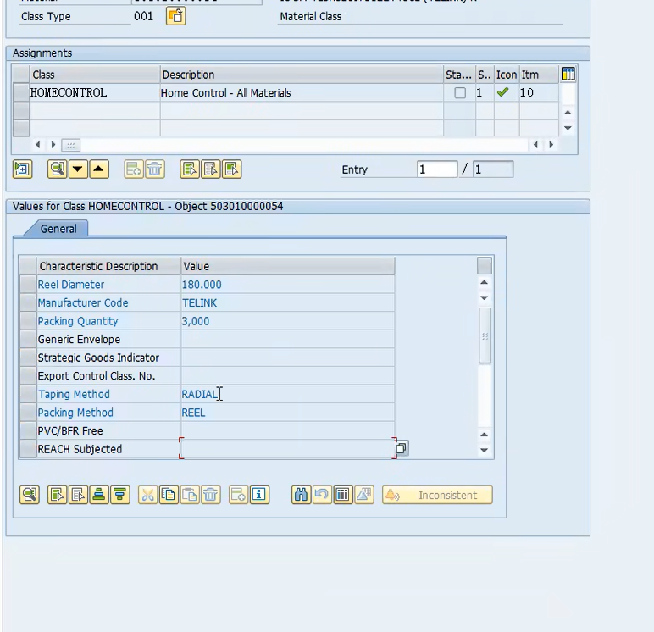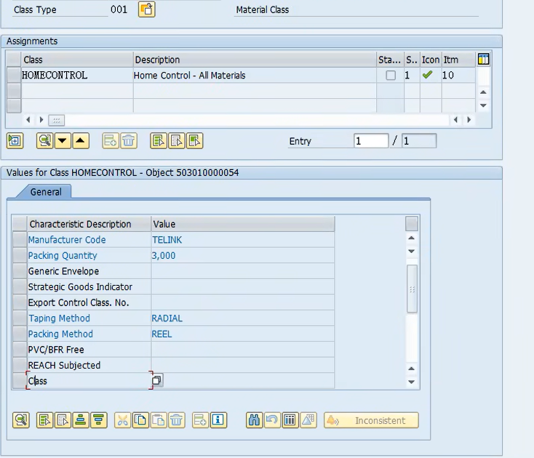
- Home Control will use customized SAP material statuses: （A new Status ZW）
Status | Description | Purchase | BOM Header | BOM Items | R/R msg. | Ind Reqs | F/cast | MRP msg. | LT | PO | Inv Mgt | Cost
ZA | Created | B |  |  |  | B | B | B | B |  | B | B
ZB | Pending Purchasing |  |  |  |  |  |  |  |  |  | B | B
ZC | Pending Costing |  |  |  |  |  |  |  |  |  | B
ZD | Released
ZL | LT Line Item |  |  |  |  |  |  |  |  |  | B | D
ZN | No Costing |  |  |  |  |  |  |  |  |  |  | B
ZT | FOC Gd Rcpt |  |  |  |  |  |  |  |  |  | A
ZW | no recommend | A | A | A | A | A | A | A | A |  | A
ZZ | Phase-out |  | B | B | B | B | B | B | B |  | B | D

- Purchasing Group will be maintained as "buyer" when material for repeating order.
- Product Family to be stored in Ext. Material Group in Basic Data 1 as part of the Material master. Product Family can be maintained for components while it is not a mandatory field.
- A new UOM ZPC is required to be created with decimal places in new SAP system. ZPC to be 3 decimal places.
- A custom field need to be maintained “Model” under the basic view.
- A custom field need to be maintained “Commodity Code” under the plant level.
- The fields value requirements are as follow attachment.
    - Support / Closing Considerations
- See Conversions section for details regarding material master migration (conversion) from legacy systems.

    - Integration Dependencies
- Configuration of valuation classes is dependent on finance configuration (general ledger).
- Some of material master data will be determined and detailed in other related design documents, for example MRP data requirements, Storage requirements, etc.

  - Maintain Business Partner - Supplier Master
    - Purpose
This section explains the procedure of maintaining a Supplier - Business Partner.

    - Business Reason
The vendor master database contains information about the vendors that supply an enterprise. This information is stored in individual BP master records. A Business Partner is a critical data record within the entire purchasing, receiving and payment process. The Business Partner contains key data necessary to:
- Create purchase orders
- Receiving shipments and Process incoming materials and parts receipts
- Create manual invoices with /without 3-way match
- Generate payment documents and Vendor payment processing
- Process invoices using 3-way match (PO – Goods receipts and Invoices). The BP master is required for all types of transaction required in the Purchase to Pay process.
- Supplier evaluation and reporting
A Business Partner record contains the vendor’s name and address, as well as data such as:
- Name, address, tax ID
- Bank data
- Payment terms and payment methods
- The currency used for ordering from the vendor
- Names of important contact persons (sales staff)
- Bank data
Since, to the accounts department, Suppliers are generally creditors (accounts payable), the Business Partner record also contains accounting information, such as the relevant control account (reconciliation account) in the general ledger.
    - Business Benefits
    - Business Process Flow
    - Business Process Steps
Step | Step Name | Role | SAP App Name | Expected Results | Comments
001 | Collect all info including bank info and fill in the application form | Requestor/  Commodity Manager | Non-SAP |  | BOM Vendor request will come from commodity manager
002 | AP validate the bank key and fill up necessary accounting data required | AP Admin | Non-SAP
003 | Approved? | Financial Controller | Non-SAP | Approved
004 | Approved? | Purchasing Director  /Site Manager | Non-SAP | Approved
005 | Approved? | Financial Controller | Non-SAP | Approved
006 | Change Supplier Master Data | Master Data Team | Maintain Business Partner/Manage Business Partner Master Data/ Manage Supplier Master Data | The supplier master data is updated.
007 | Create Supplier Master Data | Master Data Team | Maintain Business Partner/Manage Business Partner Master Data/ Manage Supplier Master Data
008 | Inform Requestor/Commodity Manager the change/Creation is completed | Master Data Team | Non-SAP |  | Creation will update with the number

    - Home Control Business Requirements
- Home Control will use the following Business Partner Groups:
  - BOM/NPR Vendor group :
    - Code: Z001
    - Length : 7 digitals
    - Purpose: Define for all external procurement vendor who sells to BOM materials, FG, subcontracting, ODM/CMS or services / equipment (stationary, fixed asset) to Home Control. Home Control plant vendors also belong to this group.
  - Inter Company Vendor Group:
    - Code: Z002
    - Length : 4 digitals
    - Purpose: Define for all Home Control company vendor.
  - Employee Vendor group :
    - Code: ZEMP
    - Length : 5 digitals
    - Purpose: Define for all employees under Home Control.
  - One-Time Vendor group :
    - Code: ZCPD
    - Length : 3 digitals
    - Purpose: Define for one-time vendor under Home Control.

- Business Partner – Supplier master maintenance:
  - Requests and approval for new vendors and changes to existing vendors will out of Home Control SAP system.
  - Once maintenance request is approved, master data specialist will create or update Supplier in SAP as needed.
  - Business Partners will need to be extended to valid Purchasing Organizations that may use the same vendor.
    - R001
    - R002
    - R003
  - Business Partners will need to be extended to valid Company Code that may use the same vendor.
    - HC Delegation Of Authority
- N/A
    - Standard Documents / Settings
- N/A
    - Design Considerations / Key Assumptions

- While creating Business Partner, it is required to assign to a Grouping. The following Groupings will be used:
Grouping | Name | Number Range | Number Range | Ext
Z001 | SBMT Controlled BOM&NPR vendor | 01 | 0000100000–0009999999
Z002 | Inter Company Vendor | XX | AAAA–ZZZZ | √
ZCPD | One-time vendor | 03 | 0000000001-0000000999 | √
ZEMP | Employee | 02 | 0000010000-0000099999
- Vendors who are customers will have the master data. The number depends on which is created earlier
- The payment terms will be configured in FICO module.
- The payment methods will be configured for company codes in FICO module.
Support / Closing Considerations
- See Conversions section for details regarding vendor master migration (conversion) from legacy systems.
- The employees master data will be created by Administrator (Minting) in the APP: Manage Workforce, then the Master data team need to create supplier and supplier (Finance) role of the employee.
- The old number of employees will be maintained on business partner full name when creating.
    - Support / Closing Considerations
- N/A
    - Integration Dependencies
- The Business Partner record contains information relevant to both Accounting and Purchasing. Communication and adhering to the same data standards is critical.
- The purchasing data (Trade Vendor Purchasing Org partner role) pertaining to a vendor must have previously been maintained before you can order from the vendor.
- The accounting data (Trade Vendor Company Code partner role) pertaining to a vendor must have previously been maintained before you can enter the vendor's invoices in the system for payment.

  - Create Purchasing Info Record and Source List and Quota Arrangement
    - Purpose
Purchasing Information Record is used to store information on a vendor and a material as master data at purchasing organization or plant level. This section explains the procedure of creating a vendor business scenario.

Source List specifies the allowed (and disallowed) sources of a material for a certain plant within a predefined period. Each source is defined by means of a source list record.
Once source list is created for a material, this material can be only bought from sources of supply (vendors) in the list. Buying from vendors not on source list is not allowed.
Quota Arrangement: If a material can be obtained from various sources of supply, each individual source of supply can be allocated a quota arrangement. The quota arrangement is valid for a certain period of time and specifies exactly how the receipts are to be distributed amongst each source of supply.
Decision of quota is between Commodity Manager and Purchasing Manager. The decision will distribute to admin for follow up maintenance in SAP system. It applies in creation or change.

    - Business Reason
Purchasing Information Record serves as a source of information for Purchasing. It contains information on a specific material and a vendor supplying the material. For example, the vendor's current pricing is stored in the info record.
The info record allows buyers to quickly determine:
- Which materials have been previously offered or supplied by a specific vendor
- Which vendors have offered or supplied a specific material
The source list can serve several purposes:
- As a list approved sources of supply. A source of supply can be a vendor, a scheduling agreement, or a plant in the case of inventory transfers from other plant.
- To define a source of supply as "fixed". Such sources count as preferred sources over a certain period of time.
- To define a source of supply as "blocked" and therefore to block the external procurement of a material from specific vendors.
- To indicate which sources are relevant to MRP.
- As an aid in selecting the preferred source during the source determination process or during MRP.

    - Business Benefits
    - Business Process Flow

    - Business Process Steps

Step | Step Name | Role | Fiori App Name | Expected Results
001 | Request Final Quotation from Vendor | Purchasing | Non-SAP
002 | Indicate in the PPCA form (Create/Change) request | Purchasing | Non-SAP | Check the consistency of data, including vendor and material before filling PPCA form
003 | Submission of PPCA Form | Purchasing | BTP APP
004 | Is the status of material is ZB? |  | BTP APP | Check the status of materials
005 | Create or Change? |  | BTP APP | Create or change the info record
006 | Approved? | Purchasing Manager | BTP APP | Approval of creation or change
007 | If need to change the price | Purchasing Manager | BTP APP | If need to change price, trigger the price changing approval
008 | Approved? | Purchasing Manager | BTP APP | Approval of change price
009 | Is price rising or falling? | Purchasing Manager | BTP APP | Check if the price is rising or falling.
010 | Approved? | Purchasing Manager | BTP APP | Approval of rising price.
011 | Change the price in info record | Purchasing Admin/SE | BTP APP | Change the price in info record
012 | Change Info Record fields except for the price | Purchasing Admin/SE | BTP APP/ mass change purchasing info record | Change Info Record fields except for the price
013 | Create Info Record & Source List | Purchasing Admin/SE | BTP APP | Create Info Record & Source List
014 | Change Source List | Purchasing Admin/SE | Manage source lists | Source list is updated.
015 | Request Final Quotation from Vendor | Commodity Manager/Purchasing Mgr | Non-SAP | The quota has been confirmed.
016 | Create Quote Master Data | Commodity Manager/Purchasing Mgr | Manage Quota Arrangements | Quota arrangement is created.
017 | Change Quote Master Data | Commodity Manager/Purchasing Mgr | Manage Quota Arrangements | Quota arrangement is updated.
HC_SAP_DD_PP02_02_MM MRP Run | MM MRP Run (Sub - process) |  |  | Qutoa is considered in MRP

    - Home Control Business Requirements
- Purchasing will maintain Purchasing Info Records.
- Info records will be required for all direct materials and optional for indirect expense items.
- All direct (BOM) materials will require a source list
- Purchasing will maintain source lists based on qualifications of vendors
- Purchasing Admin will maintain quota arrangement.

    - HC Delegation Of Authority
- N/A
    - Standard Documents / Settings
- N/A
    - Design Considerations / Key Assumptions
- An info record can apply to the following organizational levels:
- Purchasing organization – applicable when pricing, lead times, etc. are shared between all plants within the same purchasing organization.
- Plant – required when pricing, lead times, etc. are different for each plant.
- Purchasing info records will contain the key data elements, including but not limited to:
- Supplier number
- Material number
- Type of info record (standard or subcontracting)
- Order unit
- The “supplier material group” field need to borrowed to maintain SE.
- Minimum order quantity
- Incoterms
- Tax indicator
- Lead time
- Price, including price validity periods and price scales
- Additional pricing conditions (discounts, surcharges, freight charges, etc.)
- PO text (PO text from info record can be adopted in the PO item and included in the PO printout).

- Below Procurement types in info records will be used by Home Control:
- Standard
A standard info record contains information for standard purchase orders.
- Subcontracting
Other types of info records available in SAP (consignment, pipeline) will not be required at go-live.
- The Source list requirement field in the purchasing data of the material master record indicates whether a source list requirement exists for a material.

    - Support / Closing Considerations
- N/A
    - Integration Dependencies
- Prerequisites for maintaining purchasing info records:
  - Material master is maintained (purchasing data)
  - Supplier is maintained (purchasing data)
- Purchasing info records along with contracts and scheduling agreements are prerequisites for source list creation
- Authorization Roles
  - Key Apps
Fiori App Name | APP ID | Purpose
Maintain Business Partner | BP | Create/Change/ Display Business Partner Record
Display Supplier List | F1861 | Display vendor list
Manage Business Partner | F3163 | Create/Change/ Display/Copy Business Partner
Manage Supplier Master | F1053A | Create/Change/ Display/Copy supplier
Manage Purchasing Info Records | F1982 | Manage (list, create, change, delete) purchasing info records
Create Info Record | ME11 | Create Purchasing Info Record (primarily for Subcontracting)
Change Info Record | ME12 | Change Purchasing Info Record
Display Info Record | ME13 | Display Purchasing Info Record
Monitor Purchasing Info Record Price | F2988 | Display purchasing info record price history
Manage Source Lists | F1859 | Manage source lists
Maintain Source List | ME01 | Maintain source list for a material
Manage material master data | F16102 | Manage material master data
Create Material | MM01 | Create Material
Change Material | MM02 | Change Material
Display Material | MM03 | Display Material
Manage Quota Arrangements | F1877 | Maintain quota arrangement

  - Authorization Roles
Business Role | Key Tasks | Org Level Restrictions
Material Master Admin | Maintain material master (create, change, mark for deletion) | No org level restrictions in display mode
Purchasing Admin | Maintain purchasing info records, source lists | Purchasing organization
Business Partner Supplier Admin | Maintain BP - Supplier (create, change, block for posting, mark for deletion) | Purchasing organization, company code
Purchasing Manager | Approve purchasing info records, source lists
MM Master Data Display | Display MM master data – materials, vendors, info records, source lists. | No org level restrictions in display mode
- Document Types and Document Flow
Document Type | Document Flow
N/A | N/A
- Reports, Interfaces, Conversions, Enhancements, Forms, and Workflows
  - Reports
    - Standard Reports
This solution is pre-configured to include the following Standard Reports.

Fiori App | Description / Usage | Scenario#
Display Supplier List | Display vendor list | 3.2
Manage Business Partner | Create/Change/ Display/Copy Business Partner | 3.2
Manage Supplier Master | Create/Change/ Display/Copy supplier | 3.2
Manage Purchasing Info Records | Manage (list, create, change, delete) purchasing info records | 3.3
Monitor Purchasing Info Record Price | Display purchasing info record price history | 3.3
Manage Source Lists | Manage source lists | 3.3
Manage material master data | Manage material master data | 3.1
Manage Quota Arrangements | Maintain quota arrangement | 3.3
Manage Commodity code | Maintain commodity code | 3.1

    - HC Requested Reports
Home Control has requested the following additional reports.
Reports
Report Name | Description | Key Files | Std.  SAP App/Rprt | Complexity | Comment
Material info record LT change history | Display LT history of info record |  |  | Medium
  - Interfaces
The following interfaces have been identified as in scope:
Interfaces
Interface | Description | In Scope | Complexity | Comments
Material Master data | Material Master data | Yes | Medium | With Smart-Fulfillment System
Commodity Code assign Product | Commodity Code assign Product | Yes | Medium | With Smart-Fulfillment System
Material classification | Material classification | Yes | Medium | With Smart-Fulfillment System
Info record interface | Info record interface change Purchasing group | Yes | Medium | With Smart-Fulfillment System

  - Conversions
Business partners other than employees shall retain their original number during migration and use the system's internal serial numbers after migration.
Employees shall follow the original number ranges but use the system's internal serial numbers, and the original numbers shall be maintained in the employee's name or search term.

The following data conversions have been identified as in scope:
Conversions
Data | Source System | Import Complexity | Extract Complexity | Volume  (# items) | Complexity
Material Master | Spreadsheet | Medium | Manual | Hundreds | Medium
Business Partner |  | Complex | Complex | <1,200 | High
Purchasing Info Records | Manual | Medium | Medium | None in Legacy | Medium
Source Lists | Manual | Minimal | Medium | None in Legacy | Low
  - Programs
The following solution programs have been identified as in scope:
Programs
Program | Description | Complexity | In Scope | Comments
PPCA: mass approval (send email to approver) & create& change info record& source list | PPCA: mass approval (send email to approver) & create& change info record& source list | Very High | No | In BTP

  - Enhancements
The following solution enhancements have been identified as in scope:
Enhancements
Enhancement | Description | Complexity | In Scope | Comments
Custom fields for ZSD008-Brand/Model Name | One field use: Industry Standard Description, the other use custom field, but may cannot extend to other reports----need to extend to ZSD335 | Small | No
  - Forms
The following forms have been identified as in scope:
Forms
Form | Description | Complexity | In Scope | Comments
N/A

  - Workflows
The following workflows have been identified as in scope:
Flexible Workflow
Workflow | Description | Complexity | In Scope | Comments
Purchasing Information Record and Source List maintain | Purchasing Information Record and Source List maintain | Very High |  | In BTP
Maintain Material Master Data | Maintain Material Master Data | Med | Out of SAP

- Legend for Process Flow

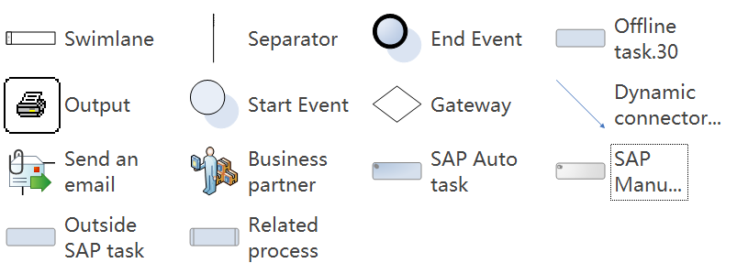

“Import Complexity” denotes the complexity involved in importing the data into SAP S/4 HANA.
“Extract Complexity” indicates the complexity involved in extracting the data from the existing legacy systems

